**Conditional GET**

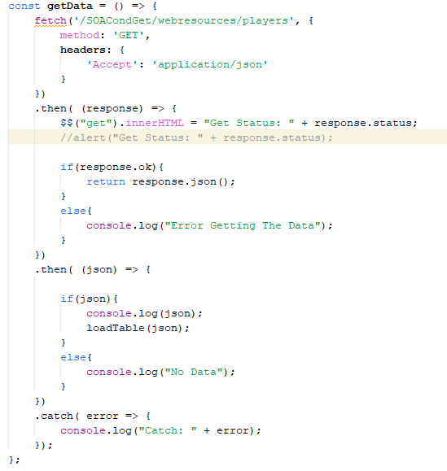

Above is the fetch GET request. This request on the client requests data from the server and a response is returned. The response will either be 200 which means that the data has changed since the last request or 304 which means there has been no modification of the data since the last GET request. This data that is returned is sent to the loadTable function which loads the data into the table using ajax.

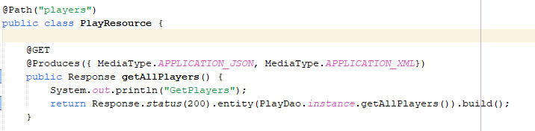

Above this is where the get request to get all the players is processed in the server. This retrieves all the players from the database and returns a response and the data along with it.